Daffodil International University
Department of Software Engineering (SWE)
Project/Thesis Committee
February 16, 2022

NOTICE
This is to notify that student who have registered for the course SWE 431/SE-431/DS 431/RE 431/ CS 431: Final Year Project/Thesis are asked to submit their Project/Thesis proposal by 28/02/2022. In order to submit the Project/Thesis proposal, students are asked to fill up the proposal form. Instruction mention below,
Before go through the instruction please join google class using Code: oyyojz4
Eligibility for Thesis/Project/Internship

- A student must be completed at least 125 Credits to Enrolled SE-431/DS 431/RE 431/ CS 431: Final Year Project/Thesis

- Thesis: Students must have 3.5 CGPA to apply for Thesis. For less CGPA Dept. and Thesis/Project Committee will decide later by their fixed criteria.

- Project: Any student can take the project but you must be followed SDLC to complete the project. We highly discourage the so-called old management system project. Students must have knowledge in both Back end and front end development for the project.

- Internship: Students must have 3.25 CGPA. Students must work on renowned software companies for internships and must work on SDLC Steps. Internship time minimum of 4 months and you must submit appointment latter to the Thesis/Project Committee. After filling all the criteria the Thesis/Project Committee will inform you about the result. If the result is negative then you have to take the project to complete your degree.

- No group allowed, Individual Task .

- Go to website (http://swe.application.daffodilvarsity.edu.bd/final_project/public/register)
- Complete Registration (Fill up Name, Valid email address, Password)
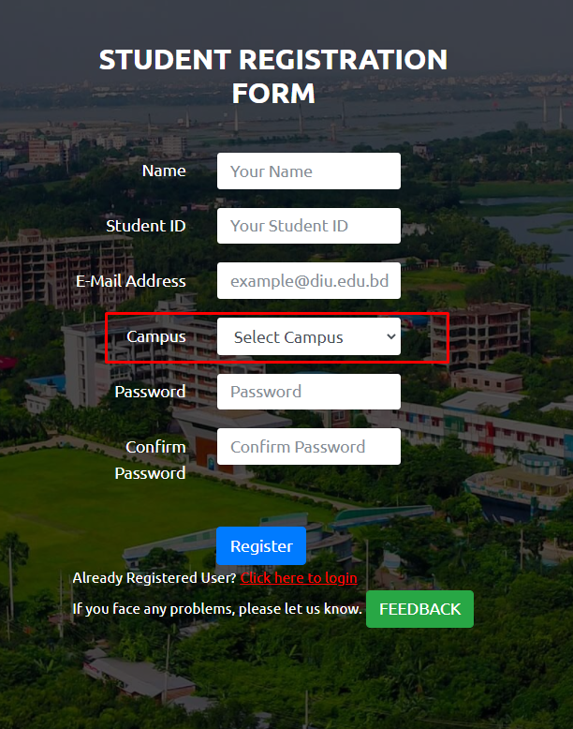

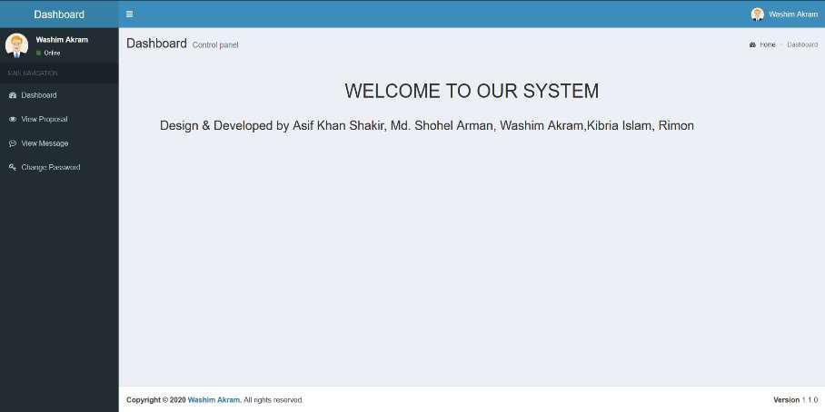
.

- If you are already registered you can be logged in using your student email id and your password.

Url: http://swe.application.daffodilvarsity.edu.bd/final_project/public/login
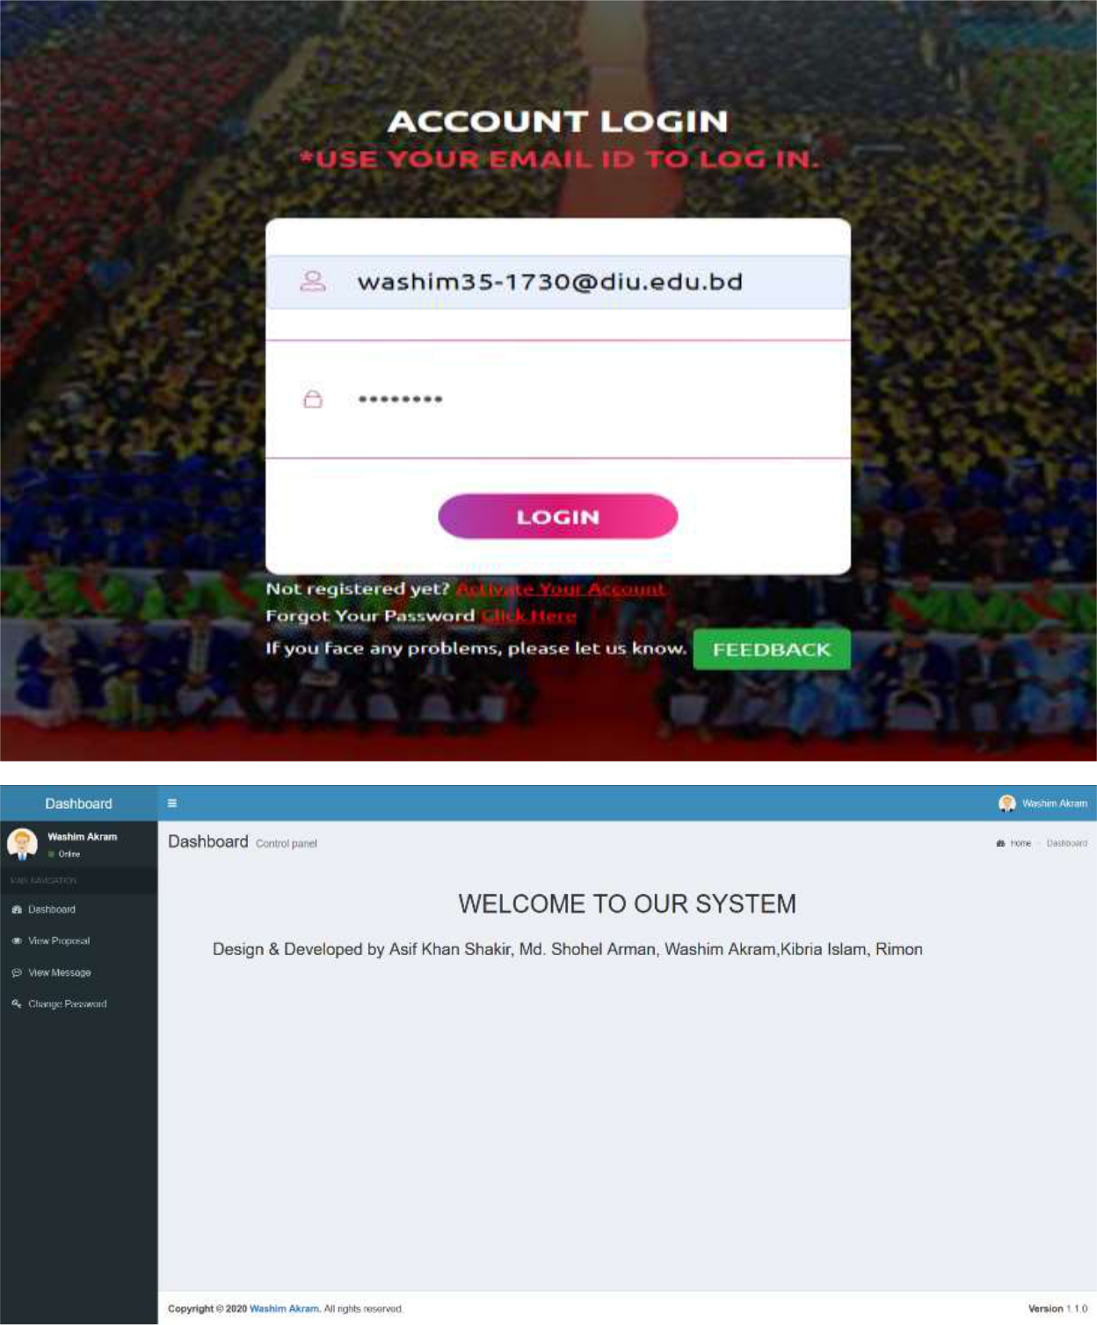

- Submit your Proposal Click Here:
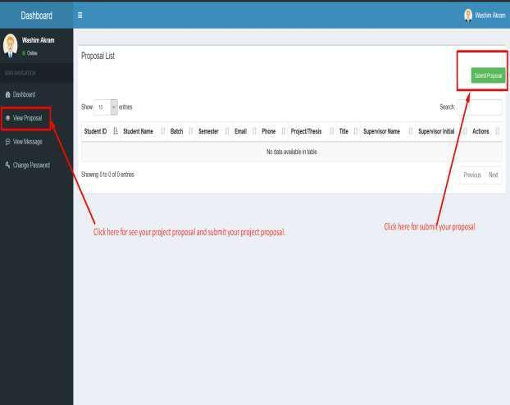

- Fill up the proposal form and click submit button. (Fill up Student ID, Batch, Semester, Phone Number, Study, CGPA, Project/Thesis/Internship, Title, Description, * If you want then you can change your name.)
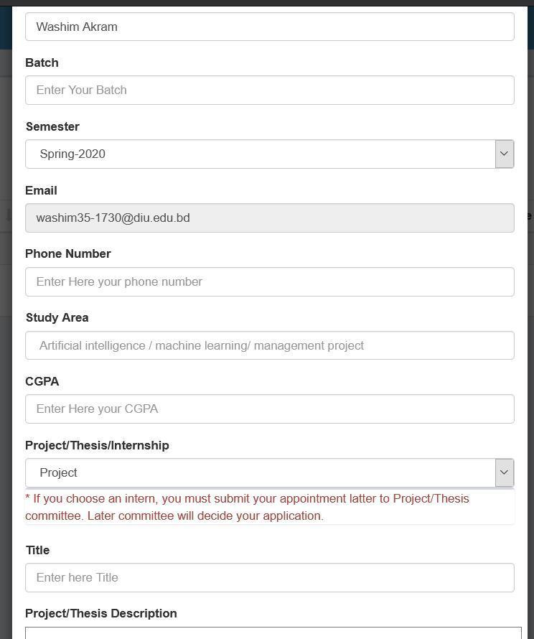

6. Click View proposal button and see your proposal accepted or pending.
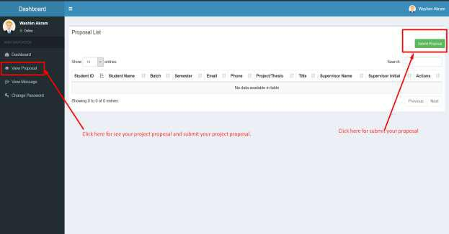
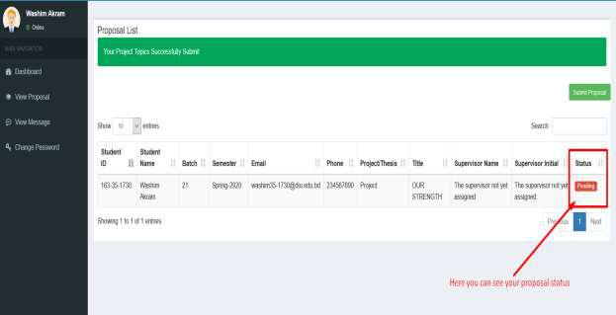
7. Click view message button and you can see your task.
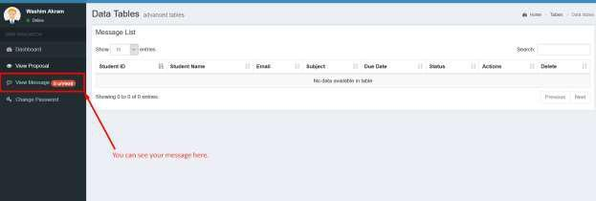

8. Click view details button then you can see details task.
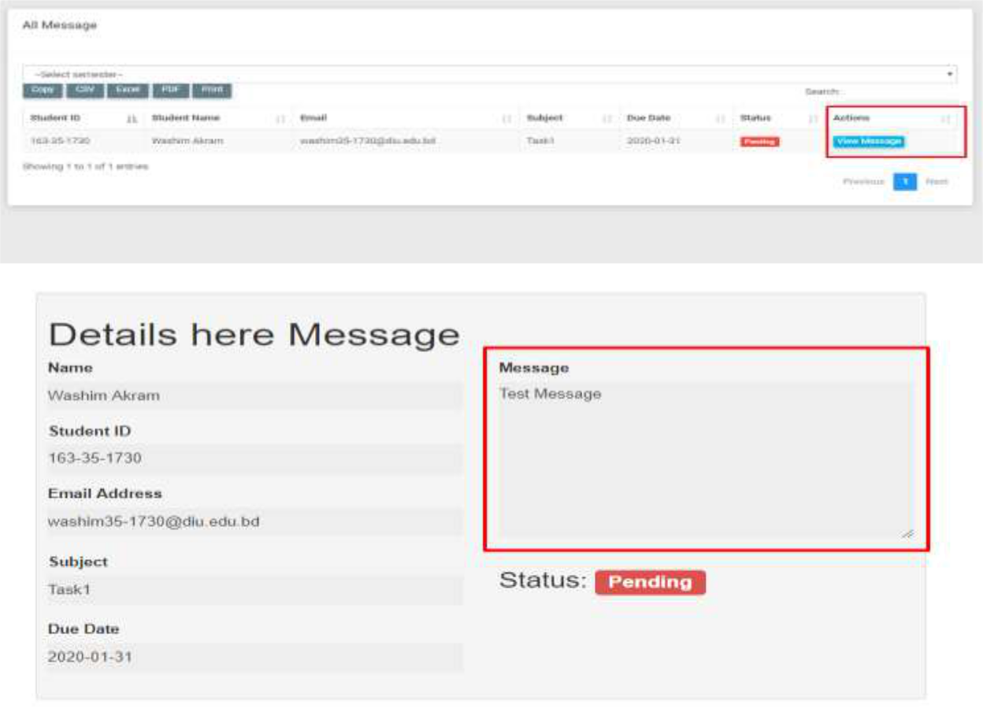
9. Here you can see notice.
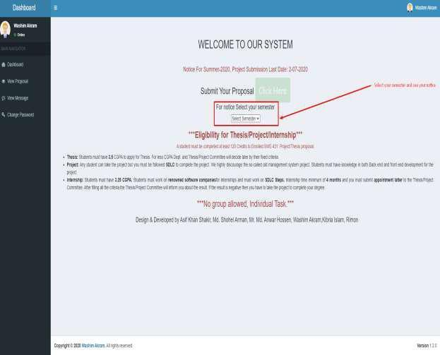

*** Join Google classroom for all the update: oyyojz4

**NB: After 28th February 2022 no proposal will be accepted,

**NB: For further queries contact with this number:
01673383289, 01673290848 & 01618401100

Syeda Sumbul Hossain, Md. Shohel Arman, Khalid Been Badruzzaman Biplob
Senior Lecturer & Member, Project/Thesis Committee Department of Software Engineering

